Truncated Icosahedron
# Source: AI Source: Provided by: [Data Path: Persons Table -> ID Column: 1, Name_En Column: Motasem Essam] -> From: [ChatGPT] on [7/25/2026]
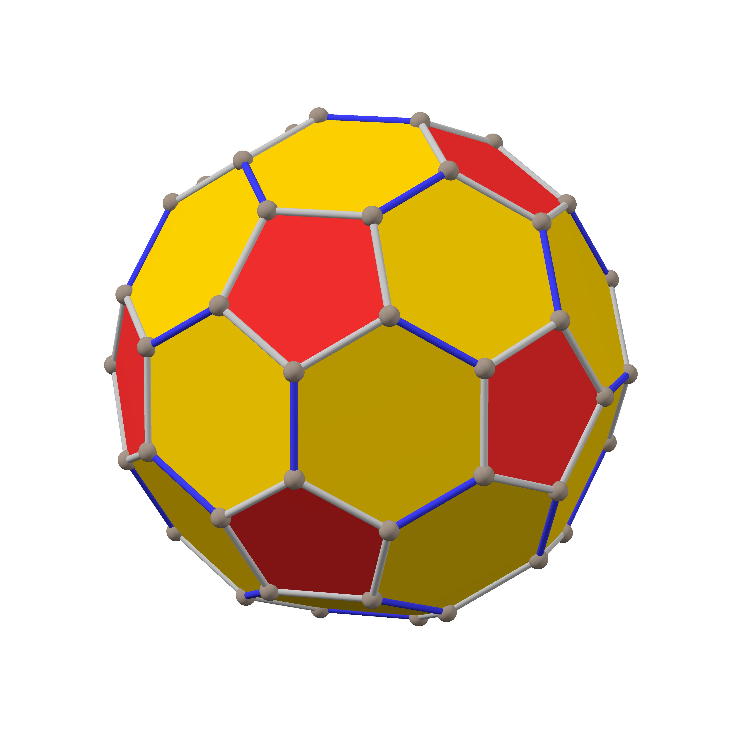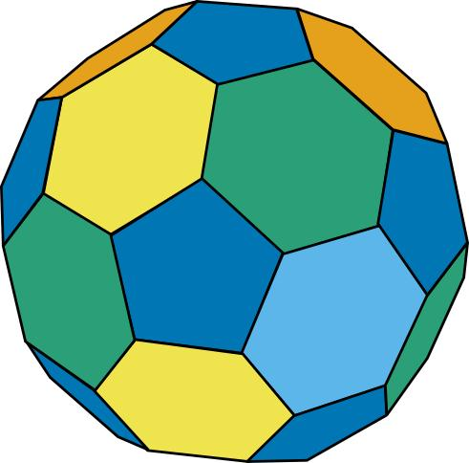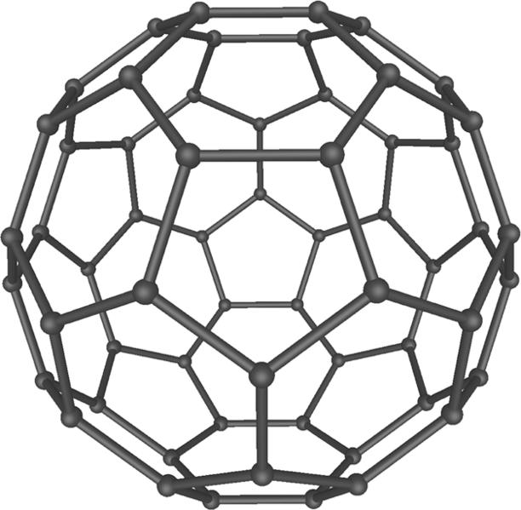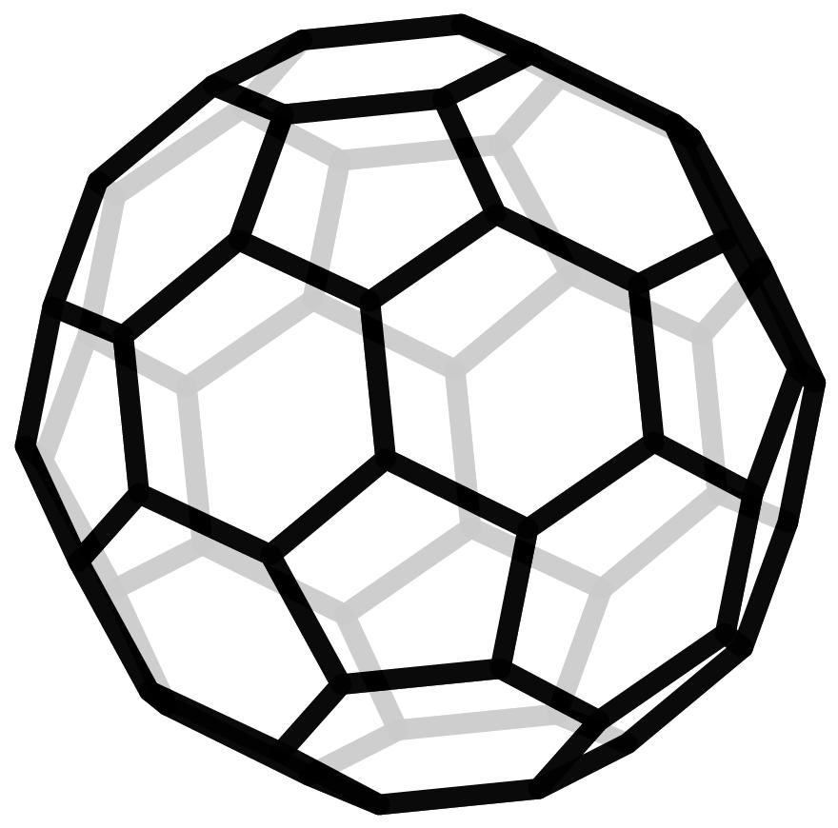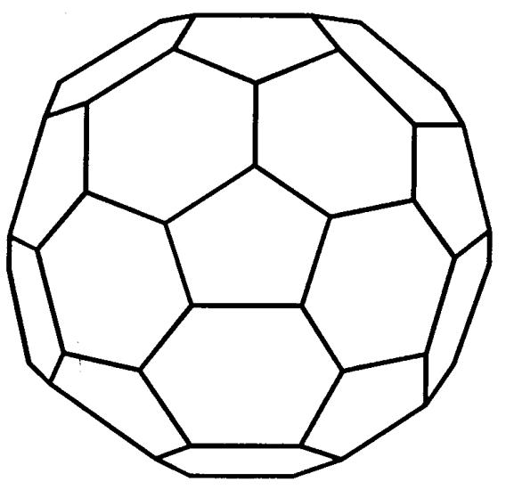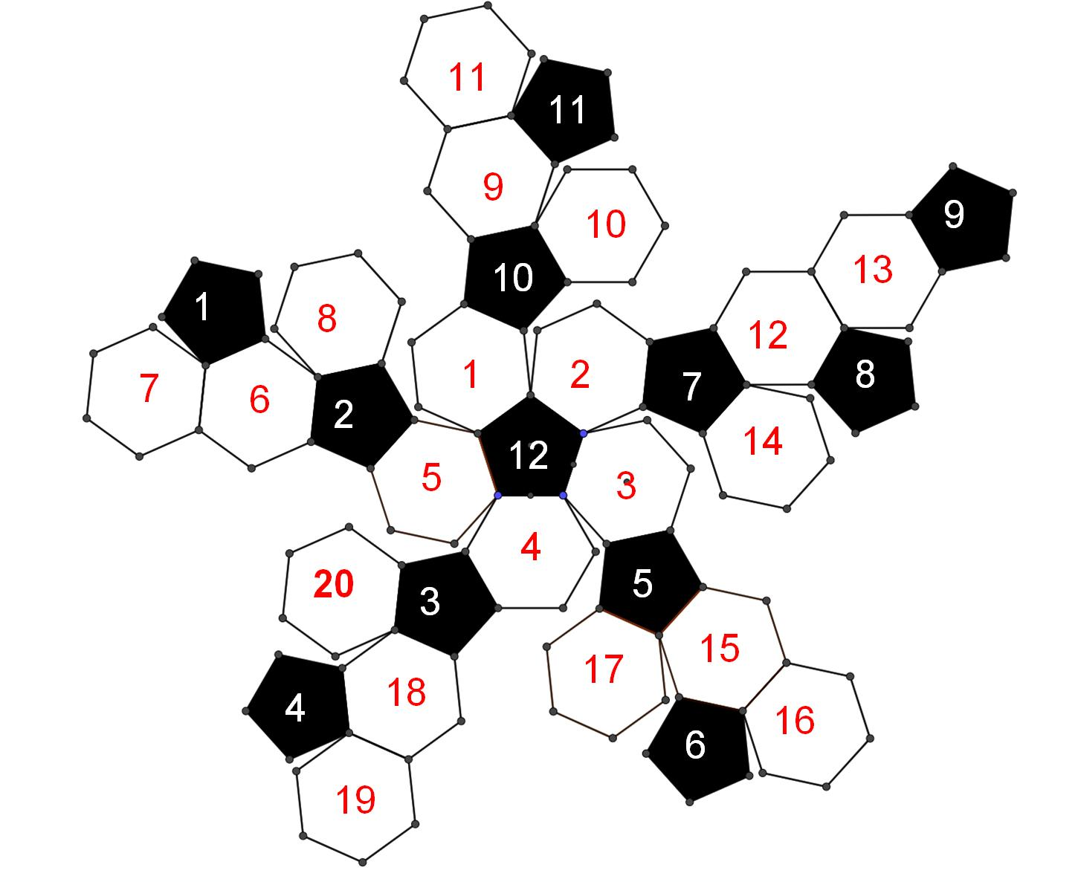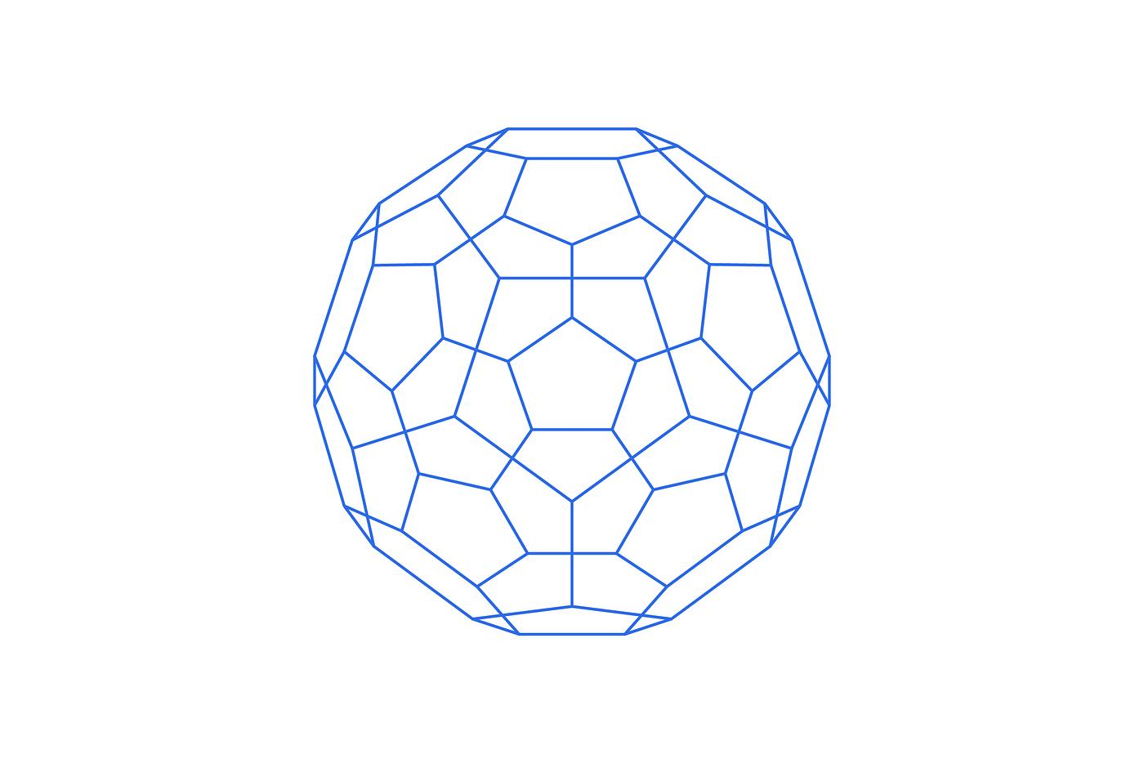

Definition
# Source: AI Source: Provided by: [Data Path: Persons Table -> ID Column: 1, Name_En Column: Motasem Essam] -> From: [ChatGPT] on [7/25/2026]
A Truncated Icosahedron is a three-dimensional polyhedron formed by cutting off the twelve vertices of an original icosahedron using planes.
The truncation process creates new pentagonal faces while modifying the original triangular faces into hexagons.

Geometric Characteristics
# Source: AI Source: Provided by: [Data Path: Persons Table -> ID Column: 1, Name_En Column: Motasem Essam] -> From: [ChatGPT] on [7/25/2026]
- Original Solid: Icosahedron
- Original Vertices: 12
- New Faces: 12 pentagons and 20 hexagons.
- Total Faces: 32
- Total Edges: 90
- Total Vertices: 60

Face Structure
# Source: AI Source: Provided by: [Data Path: Persons Table -> ID Column: 1, Name_En Column: Motasem Essam] -> From: [ChatGPT] on [7/25/2026]
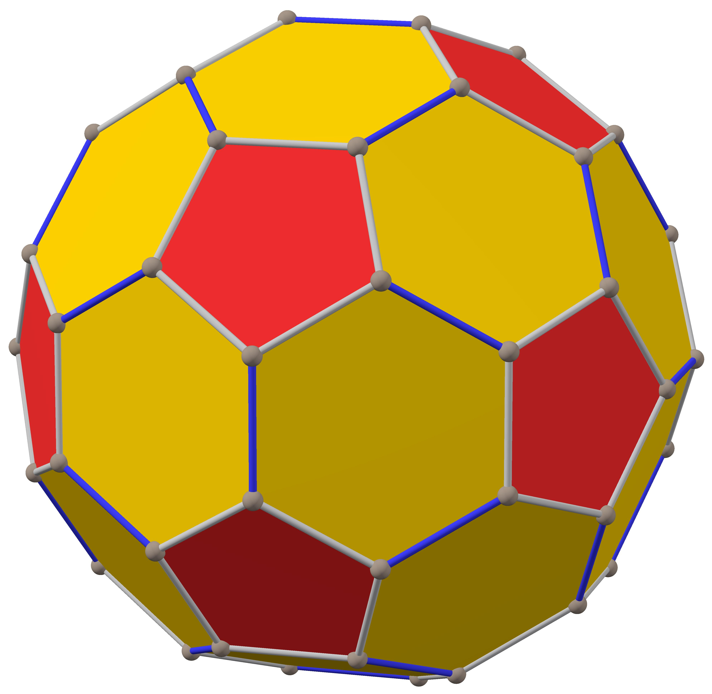
The truncated icosahedron consists of:
- 12 Pentagonal Faces: Created by cutting off the twelve original vertices.
- 20 Hexagonal Faces: Obtained by modifying the twenty original triangular faces of the icosahedron.

Mathematical Properties
# Source: AI Source: Provided by: [Data Path: Persons Table -> ID Column: 1, Name_En Column: Motasem Essam] -> From: [ChatGPT] on [7/25/2026]
Let:
- $F$ = Number of faces
- $E$ = Number of edges
- $V$ = Number of vertices

Number of Faces
# Source: AI Source: Provided by: [Data Path: Persons Table -> ID Column: 1, Name_En Column: Motasem Essam] -> From: [ChatGPT] on [7/25/2026]
$$F=12+20=\boxed{32}$$

Number of Edges
# Source: AI Source: Provided by: [Data Path: Persons Table -> ID Column: 1, Name_En Column: Motasem Essam] -> From: [ChatGPT] on [7/25/2026]
$$E=\boxed{90}$$

Number of Vertices
# Source: AI Source: Provided by: [Data Path: Persons Table -> ID Column: 1, Name_En Column: Motasem Essam] -> From: [ChatGPT] on [7/25/2026]
$$V=\boxed{60}$$

Euler's Formula
# Source: AI Source: Provided by: [Data Path: Persons Table -> ID Column: 1, Name_En Column: Motasem Essam] -> From: [ChatGPT] on [7/25/2026]
For a convex polyhedron:
$$V-E+F=2$$
Substituting:
$$60-90+32=2$$
$$\boxed{2=2}$$
Therefore, the truncated icosahedron satisfies Euler's formula.

Constructing Truncated Icosahedron in Solid Geometry

Instruments Used
# Source: AI Source: Provided by: [Data Path: Persons Table -> ID Column: 1, Name_En Column: Motasem Essam] -> From: [ChatGPT] on [7/25/2026]
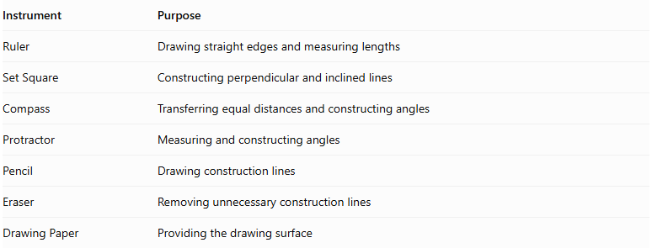
Instrument | Purpose
Ruler | Drawing straight edges and measuring lengths
Set Square | Constructing perpendicular and inclined lines
Compass | Transferring equal distances and constructing angles
Protractor | Measuring and constructing angles
Pencil | Drawing construction lines
Eraser | Removing unnecessary construction lines
Drawing Paper | Providing the drawing surface

Construction Procedures

A. Original Icosahedron-Based Construction
# Source: AI Source: Provided by: [Data Path: Persons Table -> ID Column: 1, Name_En Column: Motasem Essam] -> From: [ChatGPT] on [7/25/2026]
This method starts with a regular icosahedron and transforms it into a truncated icosahedron.
- Draw a regular icosahedron using an appropriate pictorial representation.
- Identify its 12 vertices.
- Mark equal truncation distances along the five edges meeting at each vertex.
- Connect the five marked points around each original vertex to form a pentagonal cutting boundary.
- Repeat the procedure at all 12 vertices.
- Remove or visually suppress the original corner regions.
- Identify the twenty remaining hexagonal faces.
- Darken the visible edges and distinguish hidden edges.
- Check that the resulting model contains 12 pentagonal faces and 20 hexagonal faces.

B. Edge-Based Construction
# Source: AI Source: Provided by: [Data Path: Persons Table -> ID Column: 1, Name_En Column: Motasem Essam] -> From: [ChatGPT] on [7/25/2026]
- Draw the original regular icosahedron.
- Mark equal truncation distances along its 30 edges.
- Each original edge receives two truncation marks, one near each endpoint.
- Connect the appropriate marks around each original vertex to create 12 pentagonal faces.
- Connect the remaining points on the original triangular faces to form twenty hexagonal faces.
- Refine the final solid representation.

C. Face-Based Construction
# Source: AI Source: Provided by: [Data Path: Persons Table -> ID Column: 1, Name_En Column: Motasem Essam] -> From: [ChatGPT] on [7/25/2026]
- Draw the twenty triangular faces of the original icosahedron.
- Mark truncation points along the three edges of each triangular face.
- Connect the marked points to form a hexagonal boundary inside each original triangular face.
- Construct the twelve pentagonal faces between adjacent hexagonal faces.
- Join the face boundaries into one continuous polyhedron.

D. Net-Based Construction
# Source: AI Source: Provided by: [Data Path: Persons Table -> ID Column: 1, Name_En Column: Motasem Essam] -> From: [ChatGPT] on [7/25/2026]
- Draw a net containing twelve regular pentagons and twenty regular hexagons.
- Arrange the faces so that their shared edges correspond correctly.
- Add tabs if the net will be used for physical assembly.
- Cut out the net.
- Fold along the shared edges.
- Join the corresponding edges to form the truncated icosahedron.
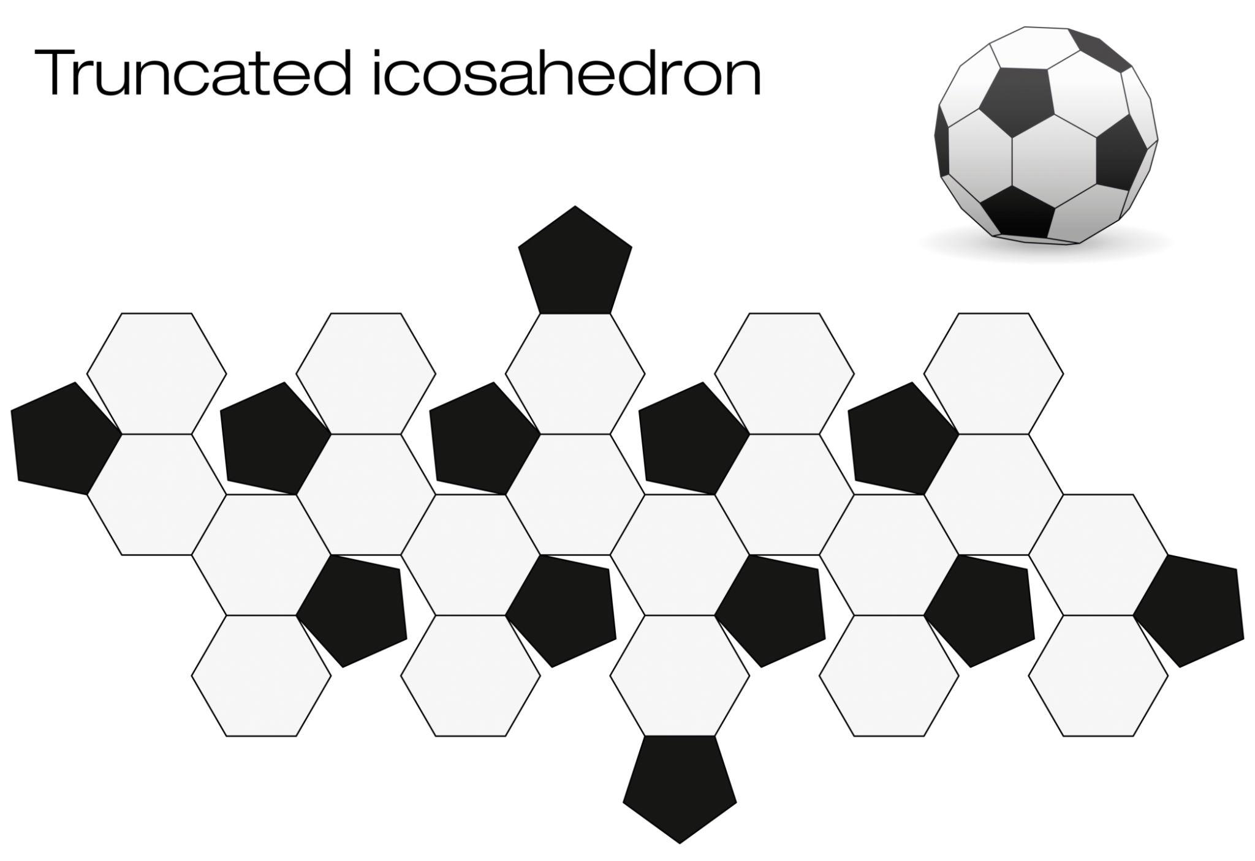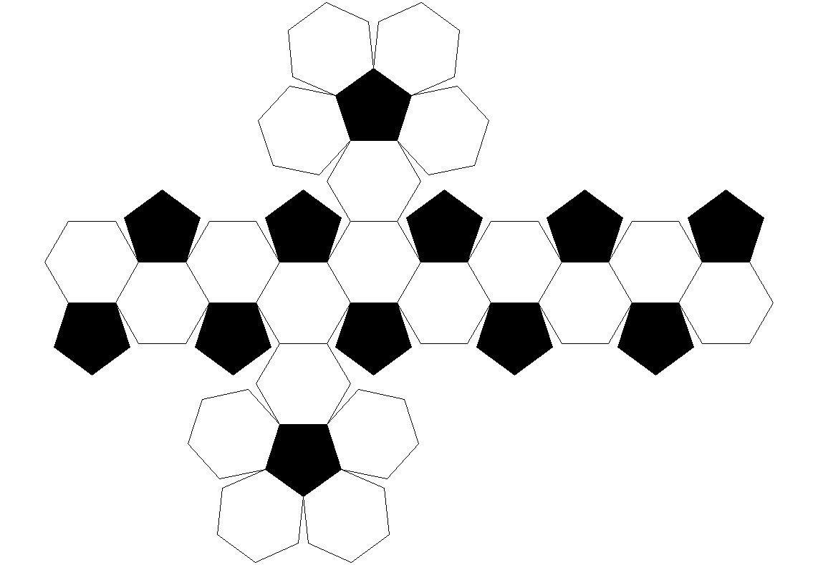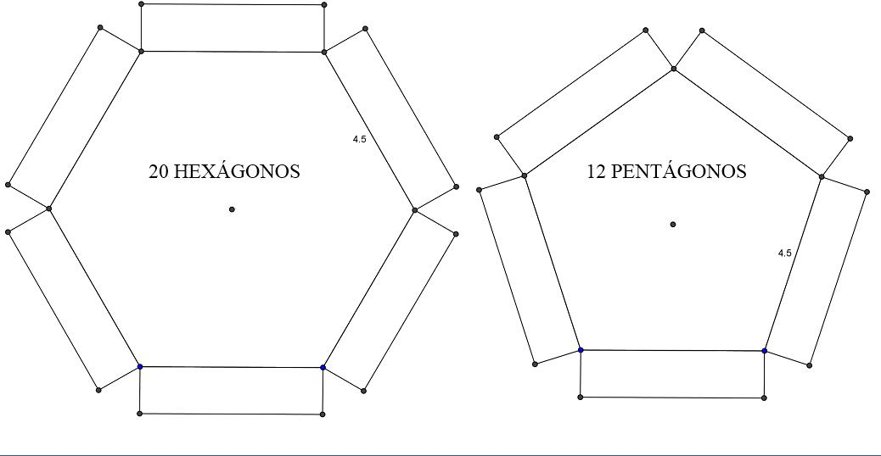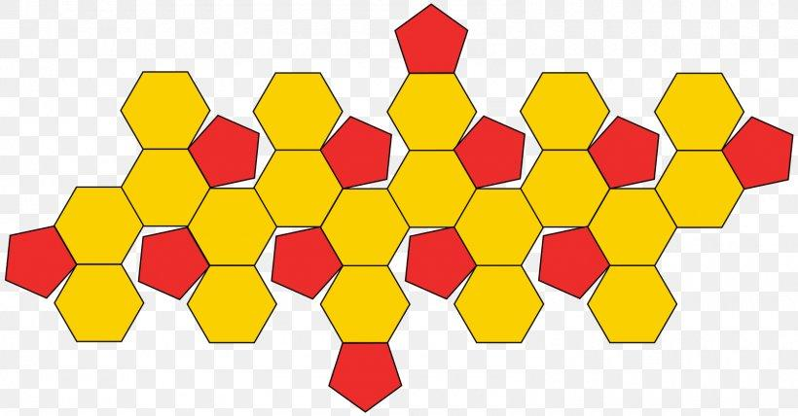

Key Points
# Source: AI Source: Provided by: [Data Path: Persons Table -> ID Column: 1, Name_En Column: Motasem Essam] -> From: [ChatGPT] on [7/25/2026]
- It is formed by truncating the twelve vertices of an icosahedron.
- It has 12 pentagonal faces and 20 hexagonal faces.
- It has 32 faces, 90 edges, and 60 vertices.
- Each original vertex produces one new pentagonal face.
- Each original triangular face becomes a hexagonal face.
- It is an Archimedean solid when uniformly truncated.

Applications
# Source: AI Source: Provided by: [Data Path: Persons Table -> ID Column: 1, Name_En Column: Motasem Essam] -> From: [ChatGPT] on [7/25/2026]
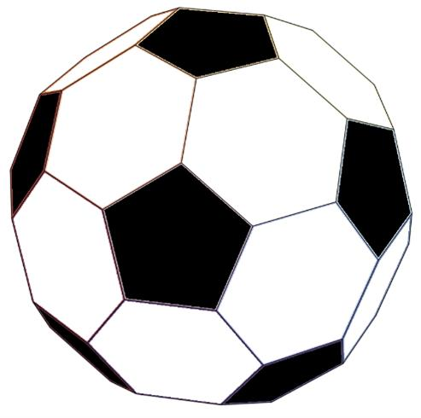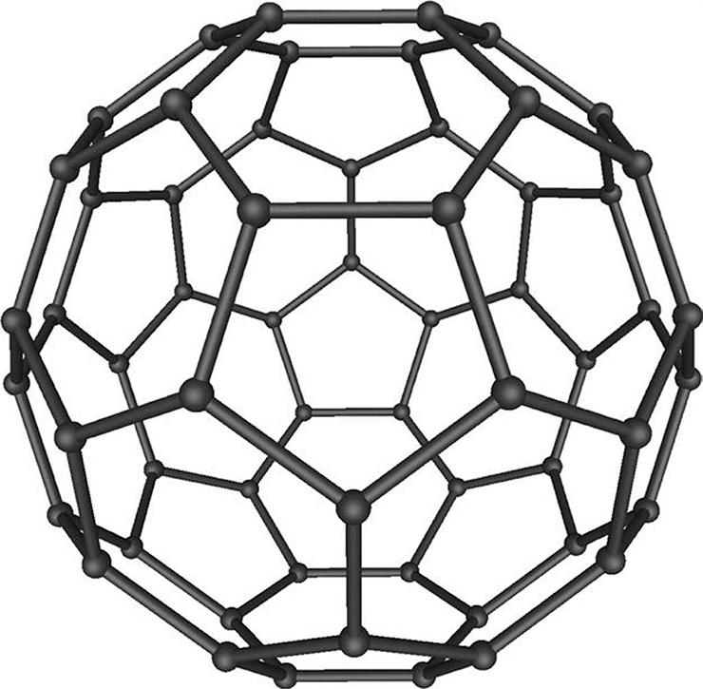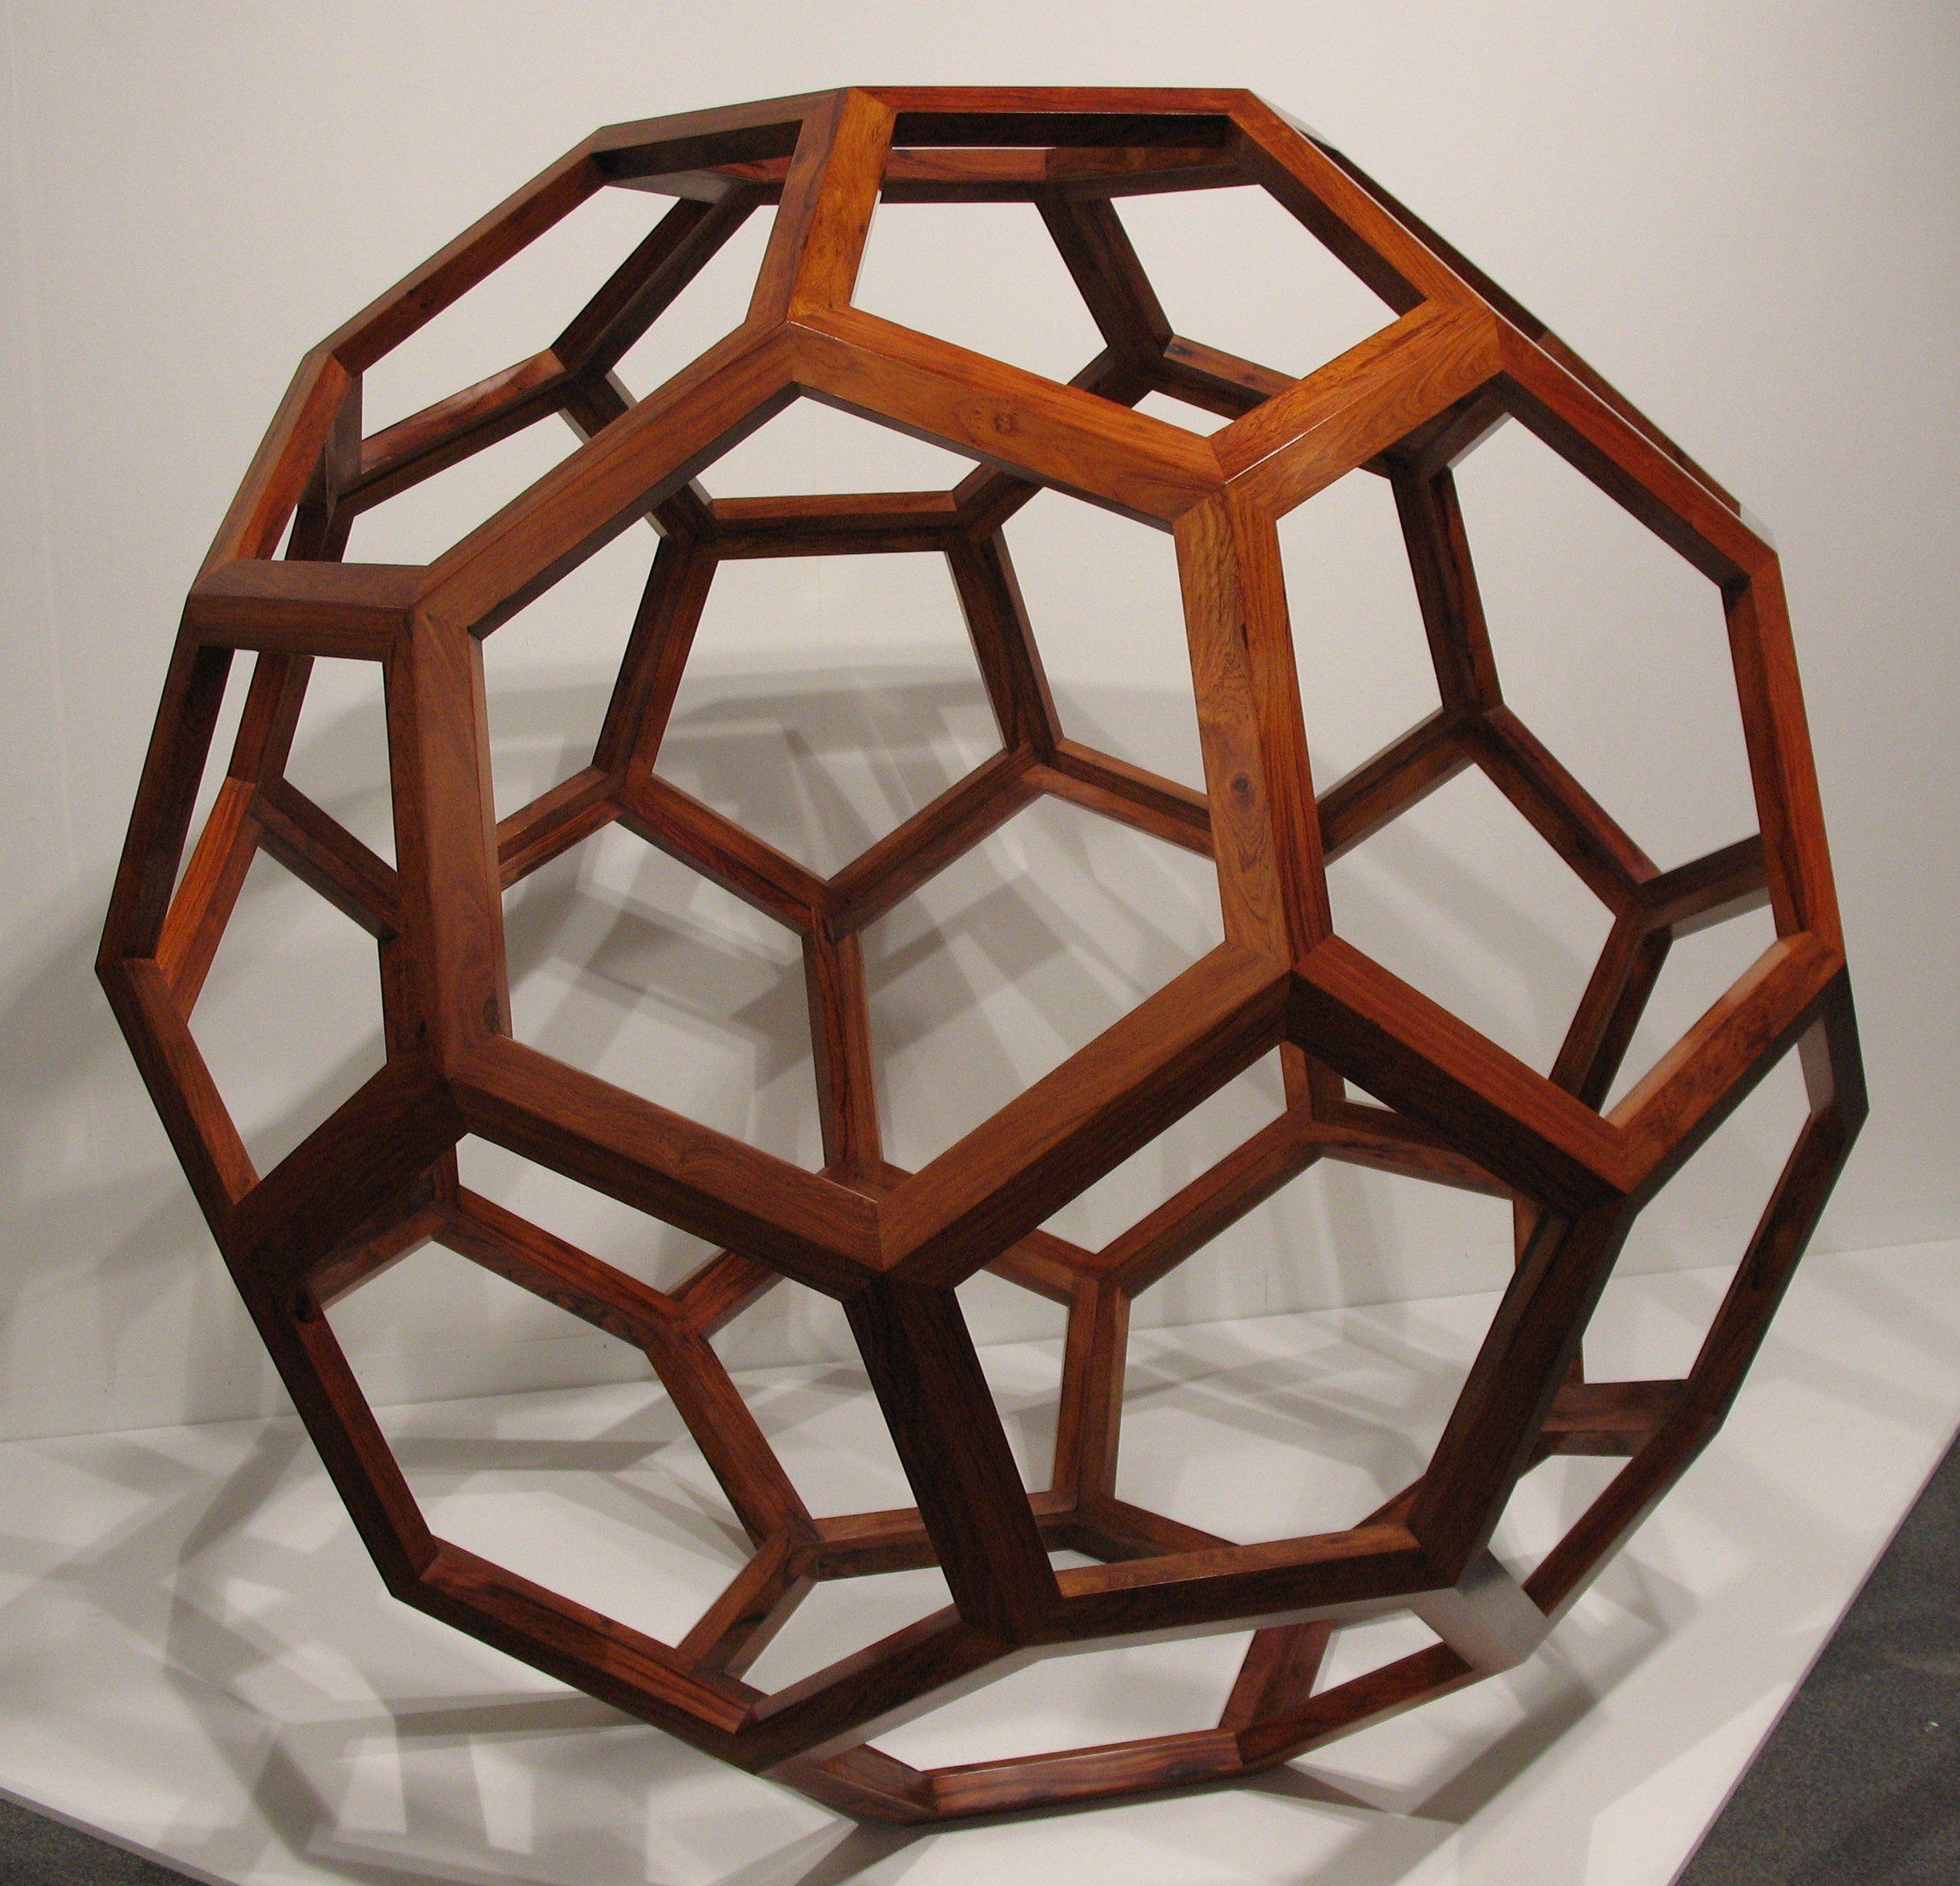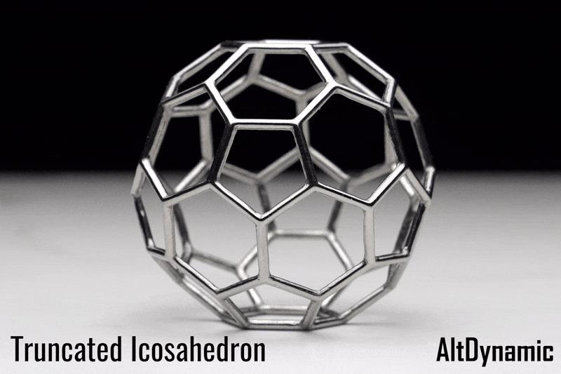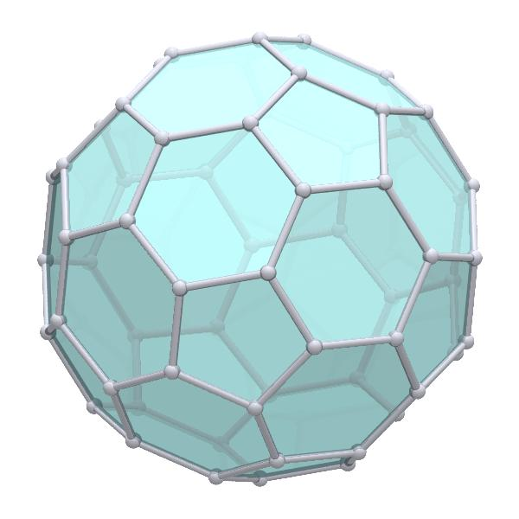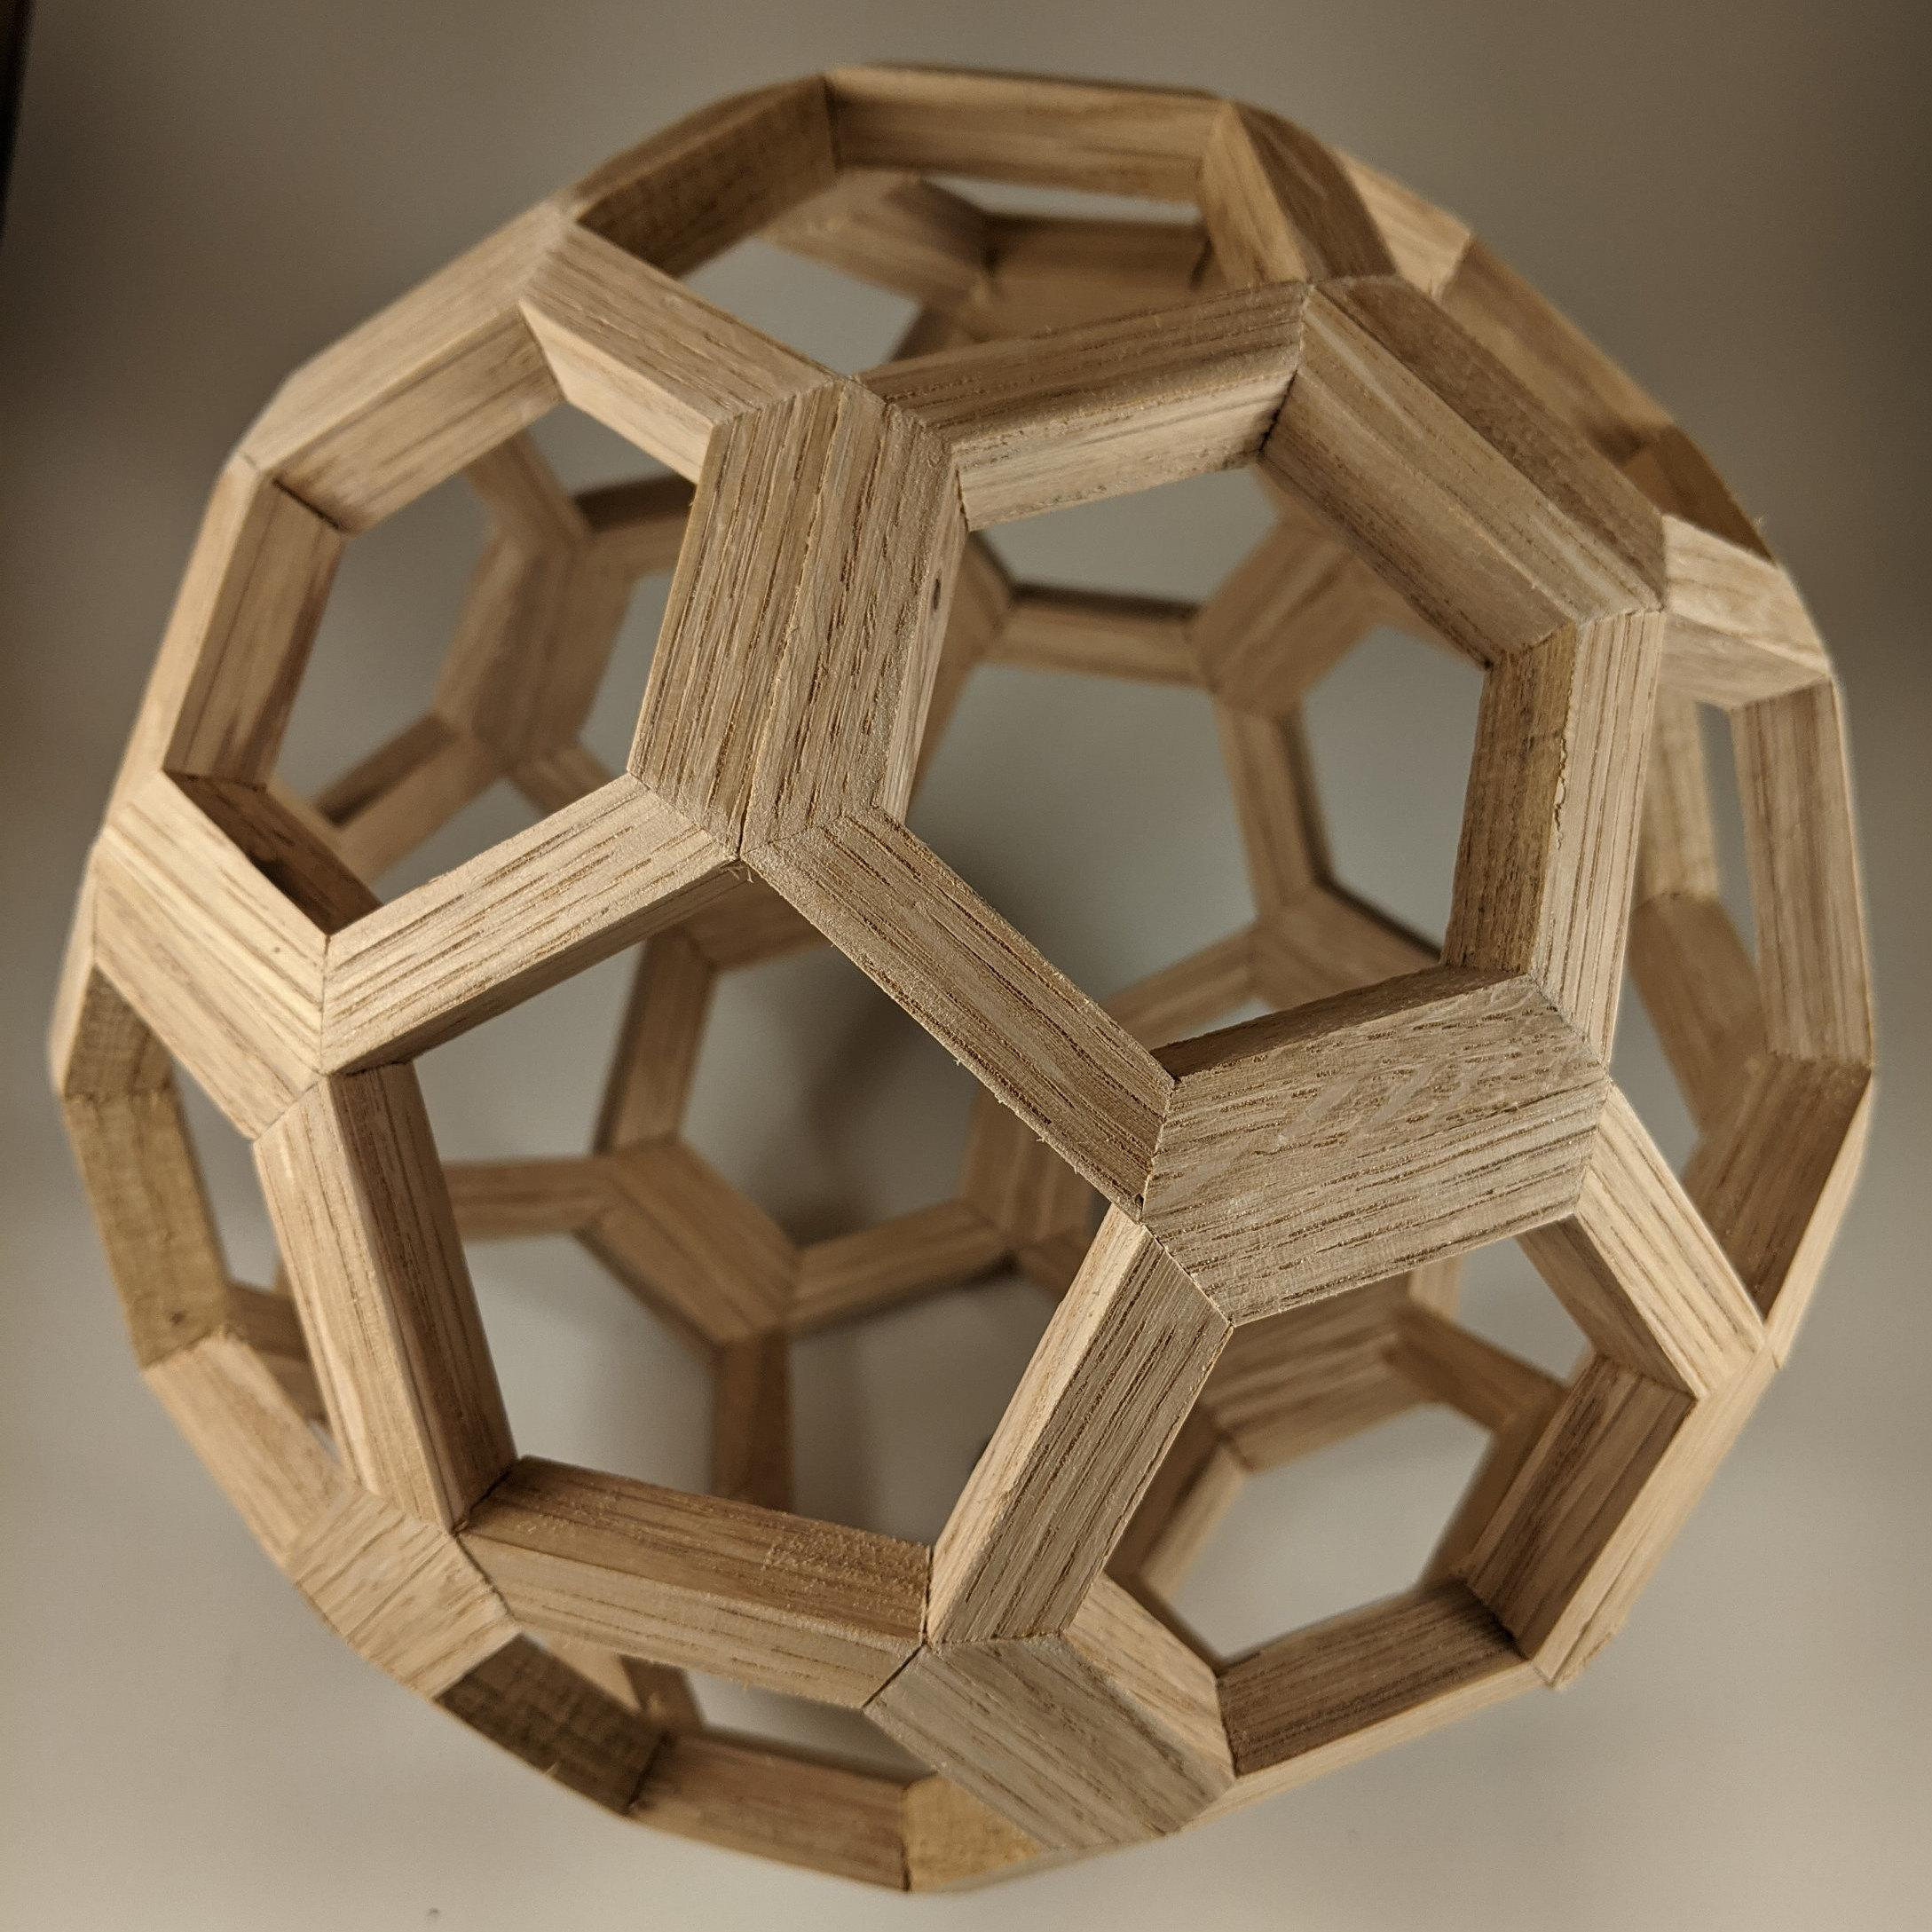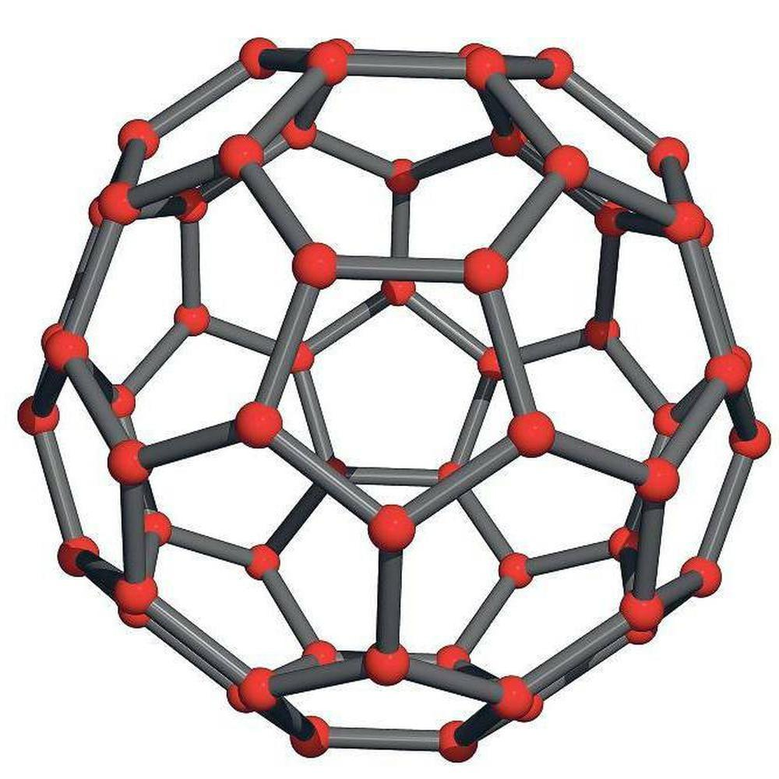
- Sports: The traditional soccer ball design is based on a truncated icosahedron.
- Chemistry: The structure of Buckminsterfullerene (C60) resembles a truncated icosahedron.
- Mathematics: Used to study polyhedra, symmetry, and geometric structures.

Conclusion
# Source: AI Source: Provided by: [Data Path: Persons Table -> ID Column: 1, Name_En Column: Motasem Essam] -> From: [ChatGPT] on [7/25/2026]
The truncated icosahedron is a three-dimensional geometric solid obtained by cutting off the twelve vertices of a regular icosahedron. It consists of twelve regular pentagons and twenty regular hexagons, creating a symmetrical solid with 32 faces, 90 edges, and 60 vertices.

